NFGLG
c/o DGLG
Offices 1-3,
Ladygrove Mill,
Ladygrove Road,
Two Dales,
Nr Matlock,
DE4 2FG

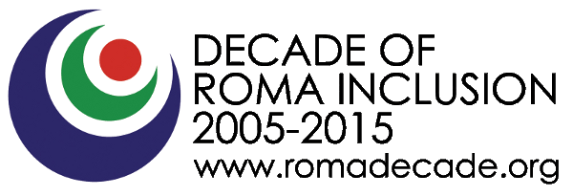
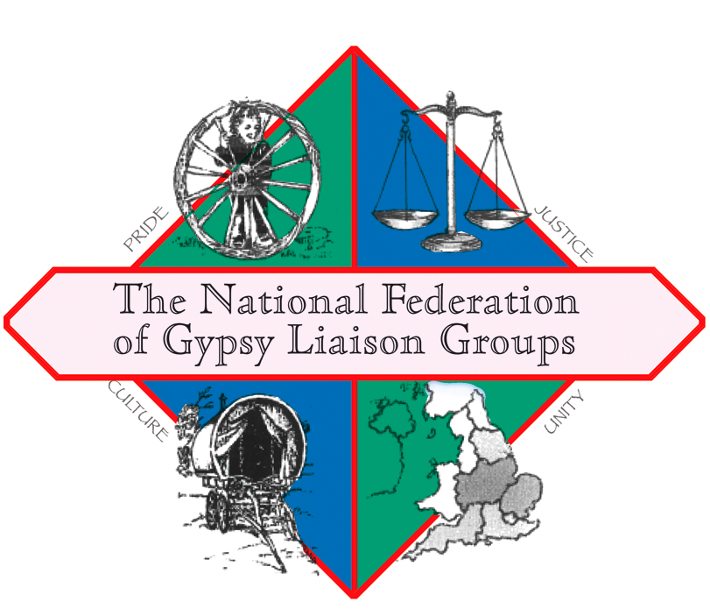

No Space For Hate

About the National Federation of Gypsy Liaison Groups

The NFGLG is a national membership-based Federation of more than 20 Gypsy, Roma and Traveller-led organisations which exists to promote the social inclusion of Gypsies and Travellers who are socially excluded, and to relieve the needs of such people and assist them in integrating into society, in particular by:
i) Providing a network group that encourages and enables members of the Gypsy and Traveller community to participate more effectively with the wider community; and
ii) Increasing or co-ordinating opportunities for members of the Gypsy and Traveller community to engage with service providers to enable those providers to adapt services to better meet the needs of that community.

About “No Space for Hate”
The project will bring together ethnic and faith communities in the West Midlands, culminating in an event focusing on race hate crime and what we as citizens and community members can do to combat it in order to produce communities that are safer, more integrated and better for all those living in them. This event will be for all communities, not just minority ethnic communities. It will be held in inner-city Birmingham, one of Britain's most ethnically diverse cities (indeed according to the 2011 Census around 42% of the city's residents were from an ethnic group other than White and Birmingham is predicted to become Britain's second plural city i.e. where no ethnicity forms a majority).

In recent years Birmingham has enjoyed better inter-ethnic relations than many towns/cities with large minority ethnic populations, but the rise of Islamophobia and anti-Gypsyism coupled with increasing activity by Far Right groups seeking to spread inter-ethnic dischord mean that the time is right to present a united front against race hate crime in all its forms.

The six community workshops we aim to hold during the project’s lifespan will work with faith and community groups to identify what hate crime is, how common it is, what forms it takes, how it affects communities and will aim to produce a strategy by which we can ensure that our communities have "no space for hate". As noted above this will culminate in an event bringing the different communities together.
Why is the project needed?
Home Office figures show that hate crimes in England and Wales rose by 18% between 2013-14 and 2014-15, with more than 80% being racially motivated. Government figures similarly show a rise in reported levels of hate crime in the West Midlands, with the highest number of offences being centred on race, while cases of religious hate crime also rose dramatically.

The alarming increases particularly in race hate crime since the “Brexit” vote have been widely commented on (e.g 'Horrible spike' in hate crime linked to Brexit vote, Met police say’, The Guardian 28.9.16), The latest set of figures released by the National Police Chiefs’ Council on Wednesday 7 September show a 49% rise in incidents to 1,863 in the last week in July when compared with the previous year. The week after saw a record 58% increase in recorded incidents to 1,787. The most recent weekly data shows that the level of hate crime is 16% higher than over a similar period last year, with 1,384 incidents reported in the third week of August, the last set of figures available.

Birmingham is one of Britain's most ethnically and religiously diverse cities and, while this diversity is generally seen as a positive attribute, inter-ethnic tensions do exist and can be exacerbated by groups coming into the city (and the West Midlands more widely) with exactly that purpose in mind. Our project seeks to address hate crime, focusing primarily (but not exclusively) on race and religious hate crime, working with community and faith groups, with young school-age people and key local agencies to present a positive message about our diverse communities and to show that there is no place for race hate in our area.

We have detailed above the alarming increases particularly in race hate crime above. In 2013-14 there were 4,683 cases of hate crime recorded in the West Midlands – an increase from 4,442 the year before. Of these 3,957 cases (84.5%) were race-related. Far Right groups such as the English Defence League have been seeking to stir up inter-ethnic and inter-religious tensions across the West Midlands, holding marches in a number of towns and cities.

We are a Gypsy-led organisation (much apocryphal data exists concerning the high incidence of race-based hate crime experienced by our community but the lack of a "Gypsy/Traveller" category in most police incident-recording systems means that this is not shown by police figures) with a national presence but we have developed close links with a wide range of Gypsy/Traveller and non-Gypsy/Traveller organisations in the West Midlands over the years, including in inner-city Birmingham. We don't, however, want to focus just on minority ethnic or minority religious communities. Hate crime affects all communities so we want to involve the maximum number of communities we can. We will work through existing organisations (many of whom we already have good working relationships with) and structures where possible, better to involve the communities they serve, but we will also seek to identify gaps and work with any communities currently excluded from existing structures to ensure that they have the opportunity to be involved in the project and that their experiences can be included.

How long will it last and who is funding it?
The project has been awarded funding by Big Lottery Fund “Awards for All”. It runs from 1st October 2016 to 30th September 2017

How to contact us
You can contact us by the following methods:
By phone: 01629 732744
By e-mail: natglg@outlook.com
You can also visit our Website: www.nationalgypsytravellerfederation.org
Follow us on Facebook:
www.facebook.com/NFGLG-427960454025702/timeline/?ref=hl

